EXP:10 Simple Stopwatch Program

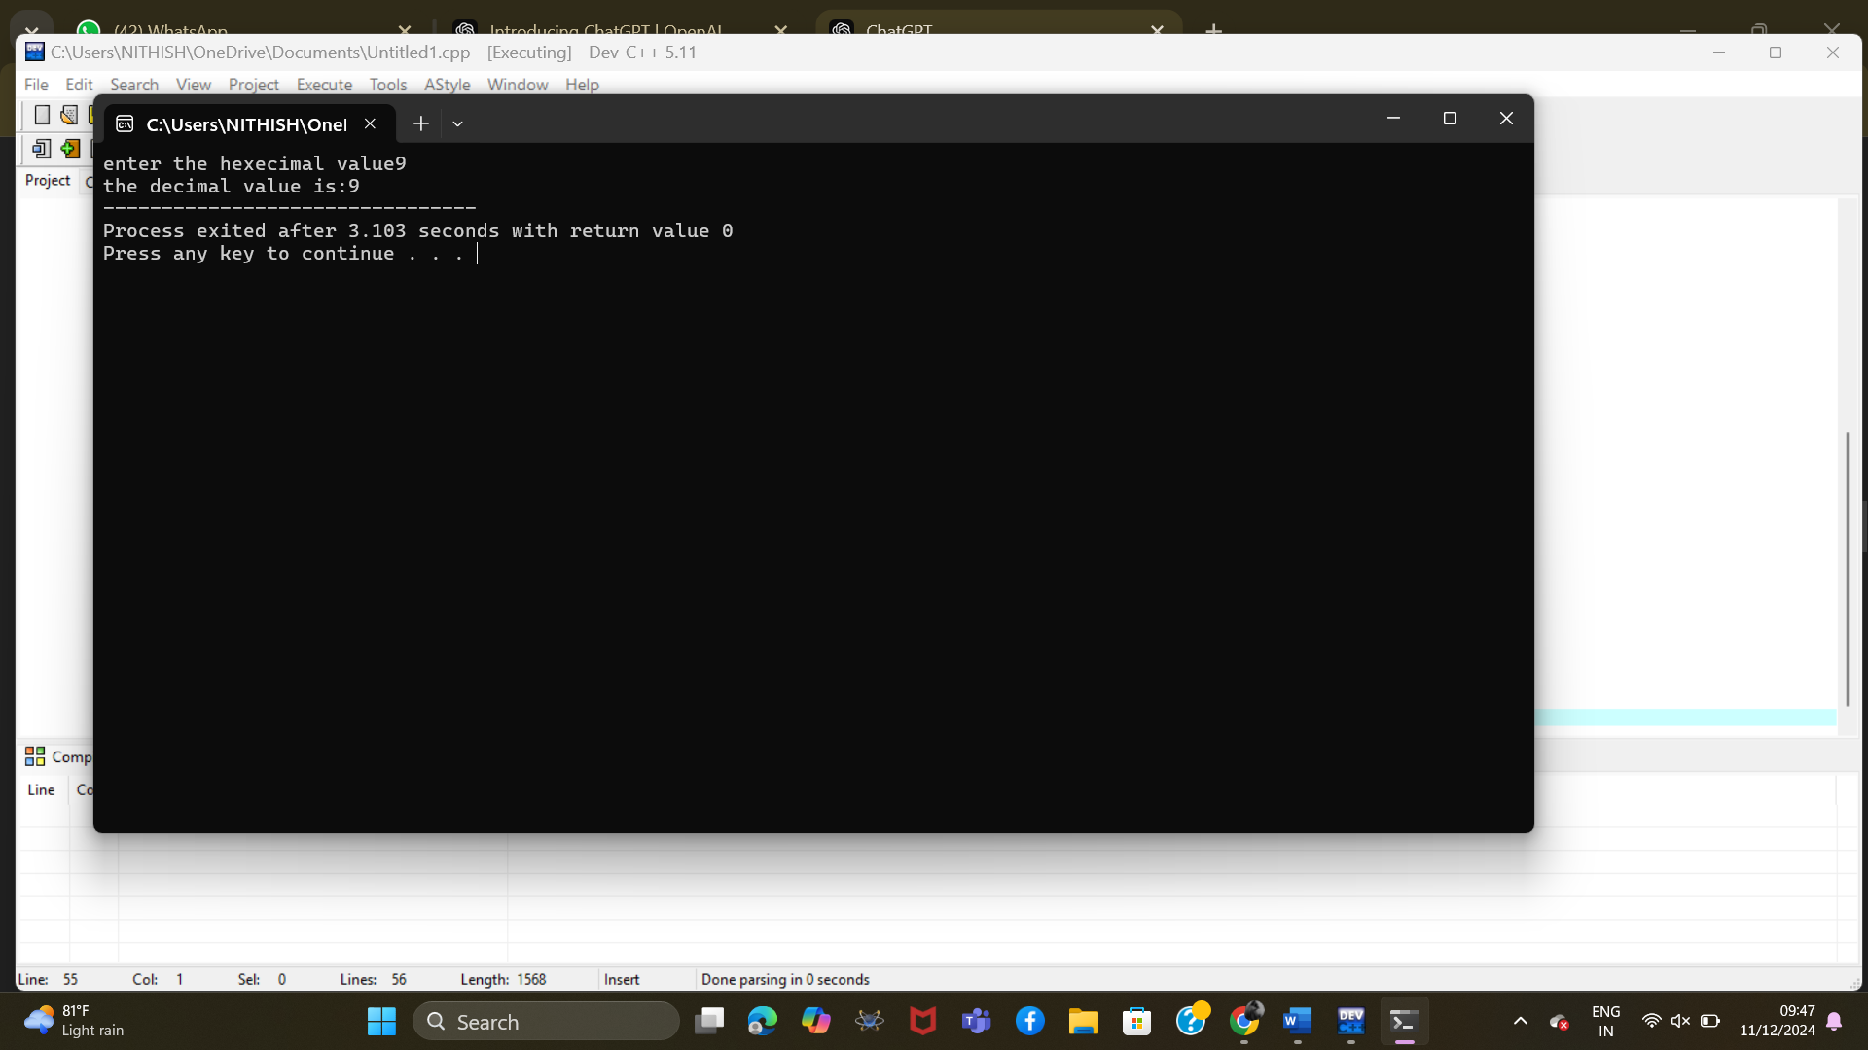

EXP:9 **Weekly Salary of a Worker**

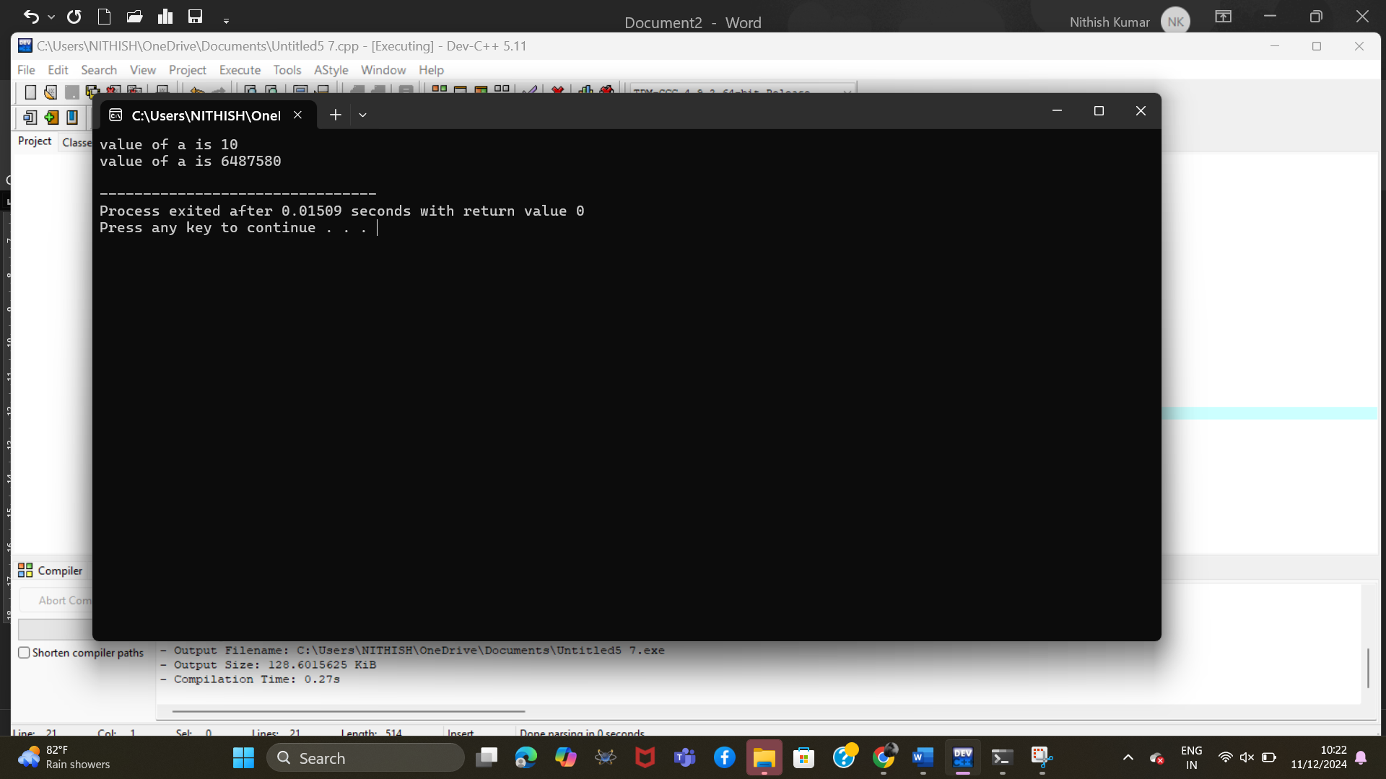

EXP:8 **. Stock Price Calculation**

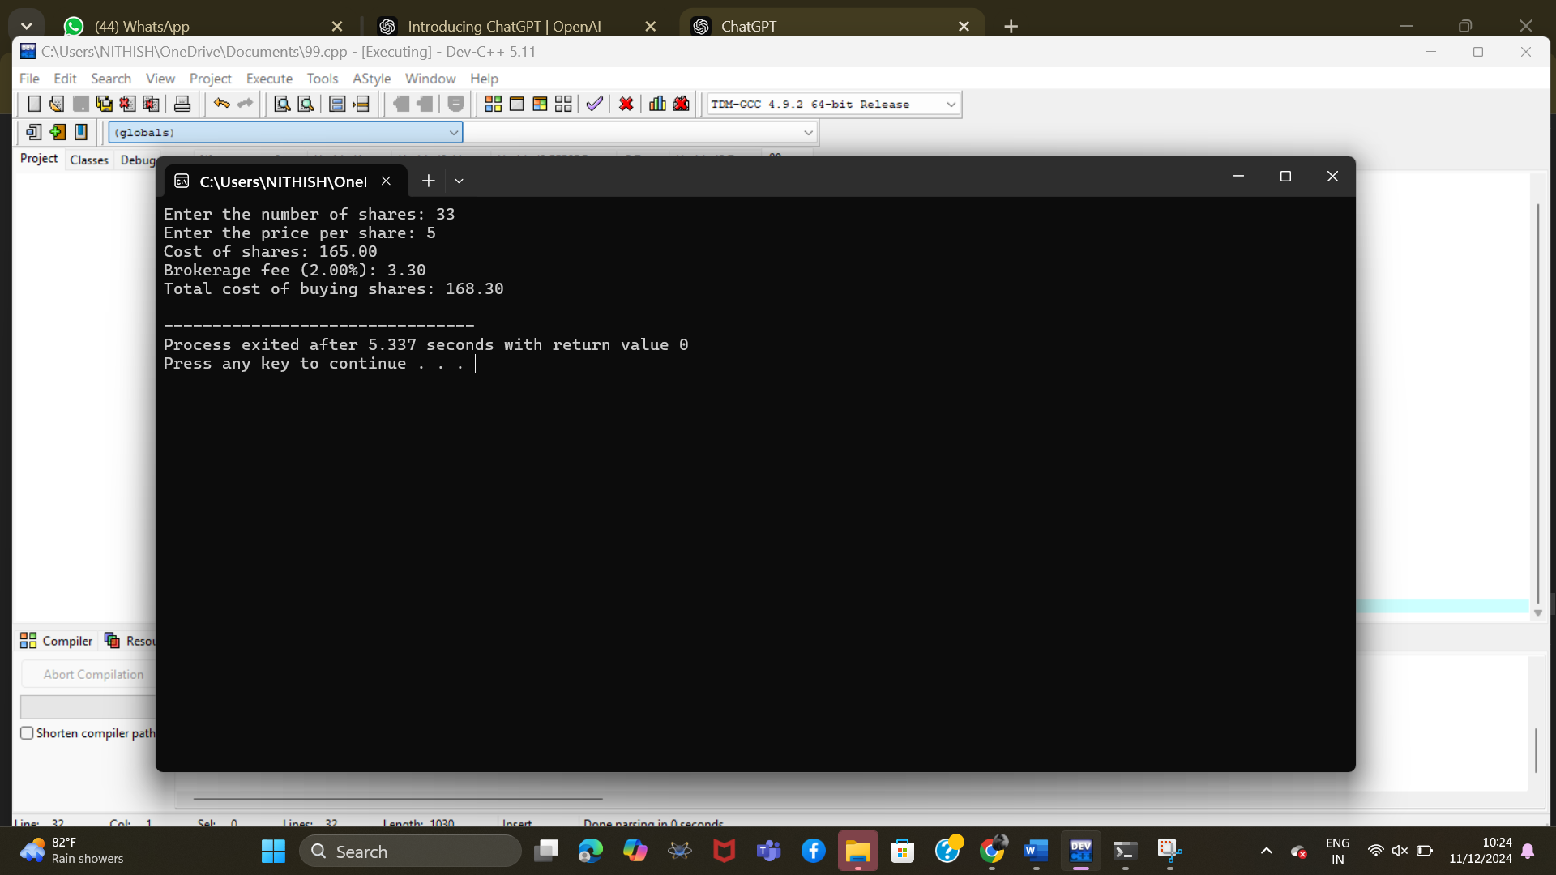

EXP:7**Exam Grade Assignment**

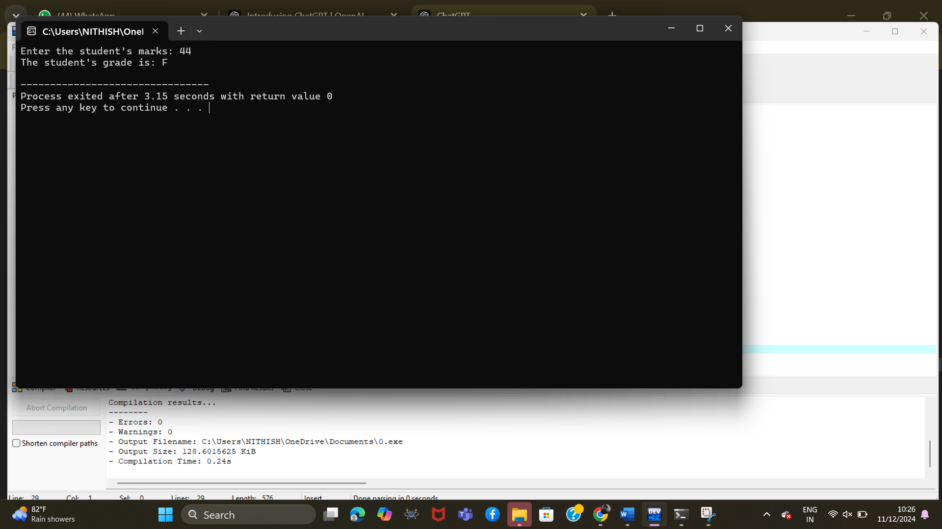

EXP:6 **. Fuel Efficiency Calculator**

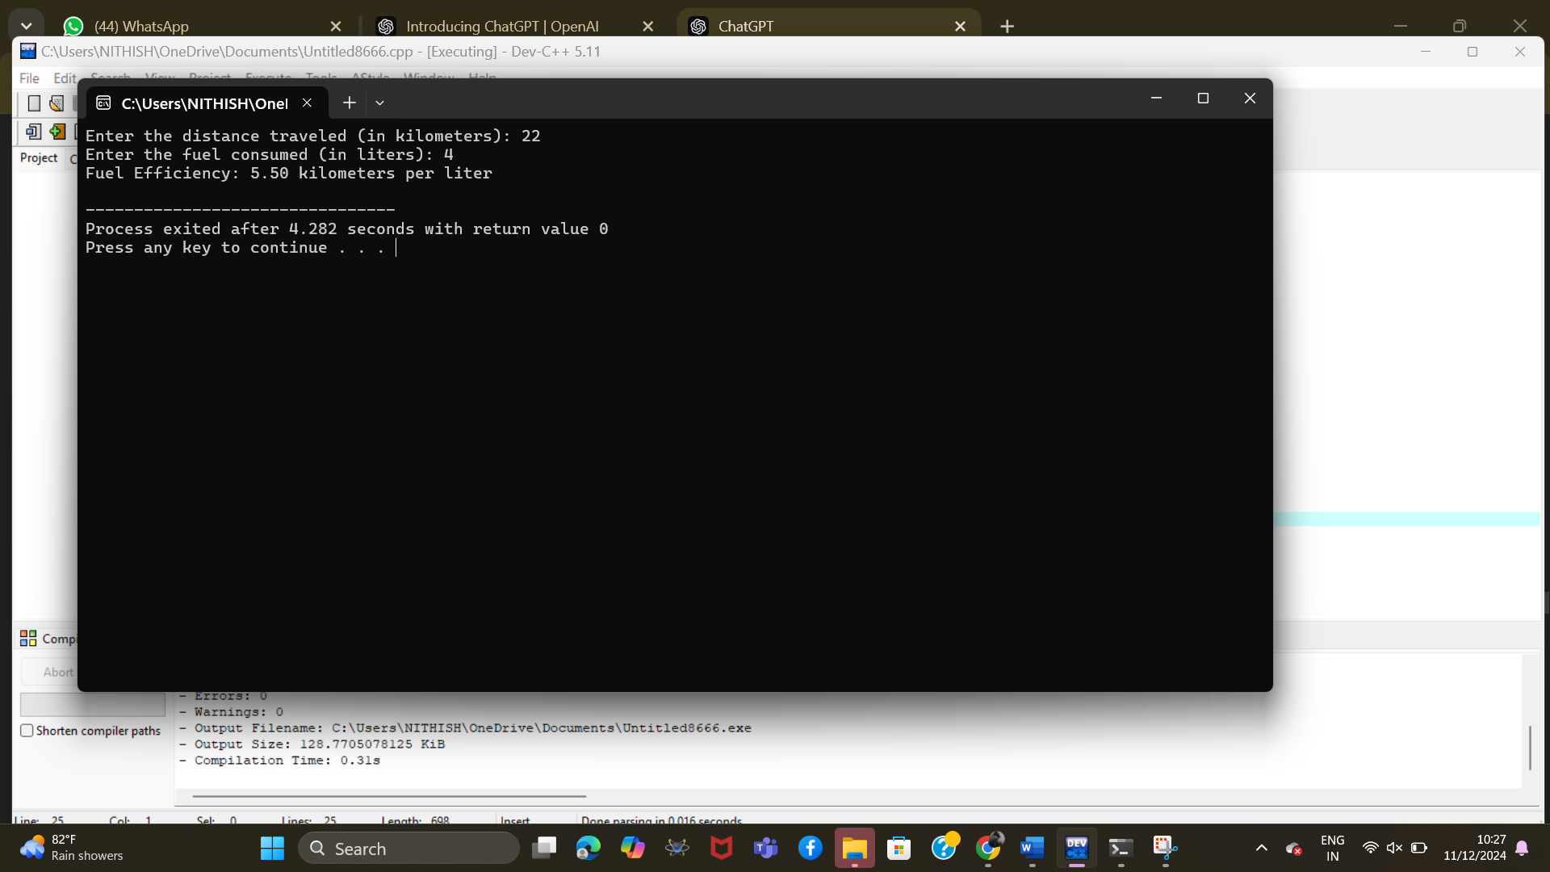

**EXP:5 . Interest Calculation in Banking**

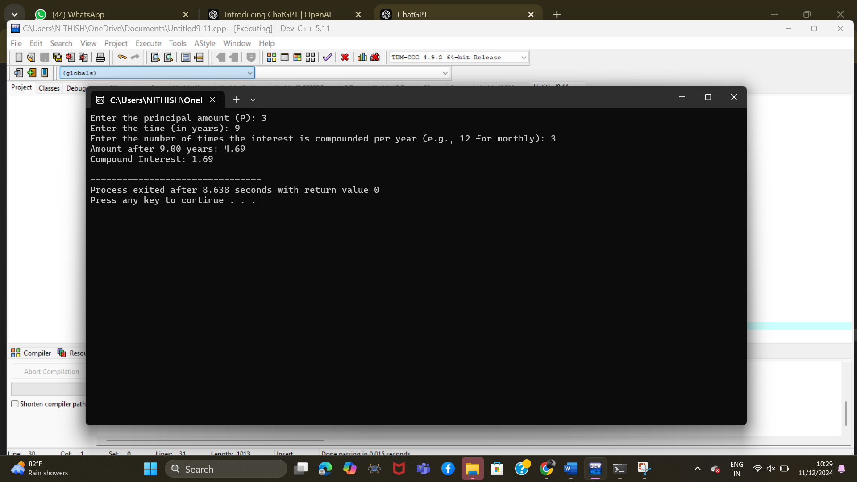

**EXP:4 Attendance Percentage Calculator**

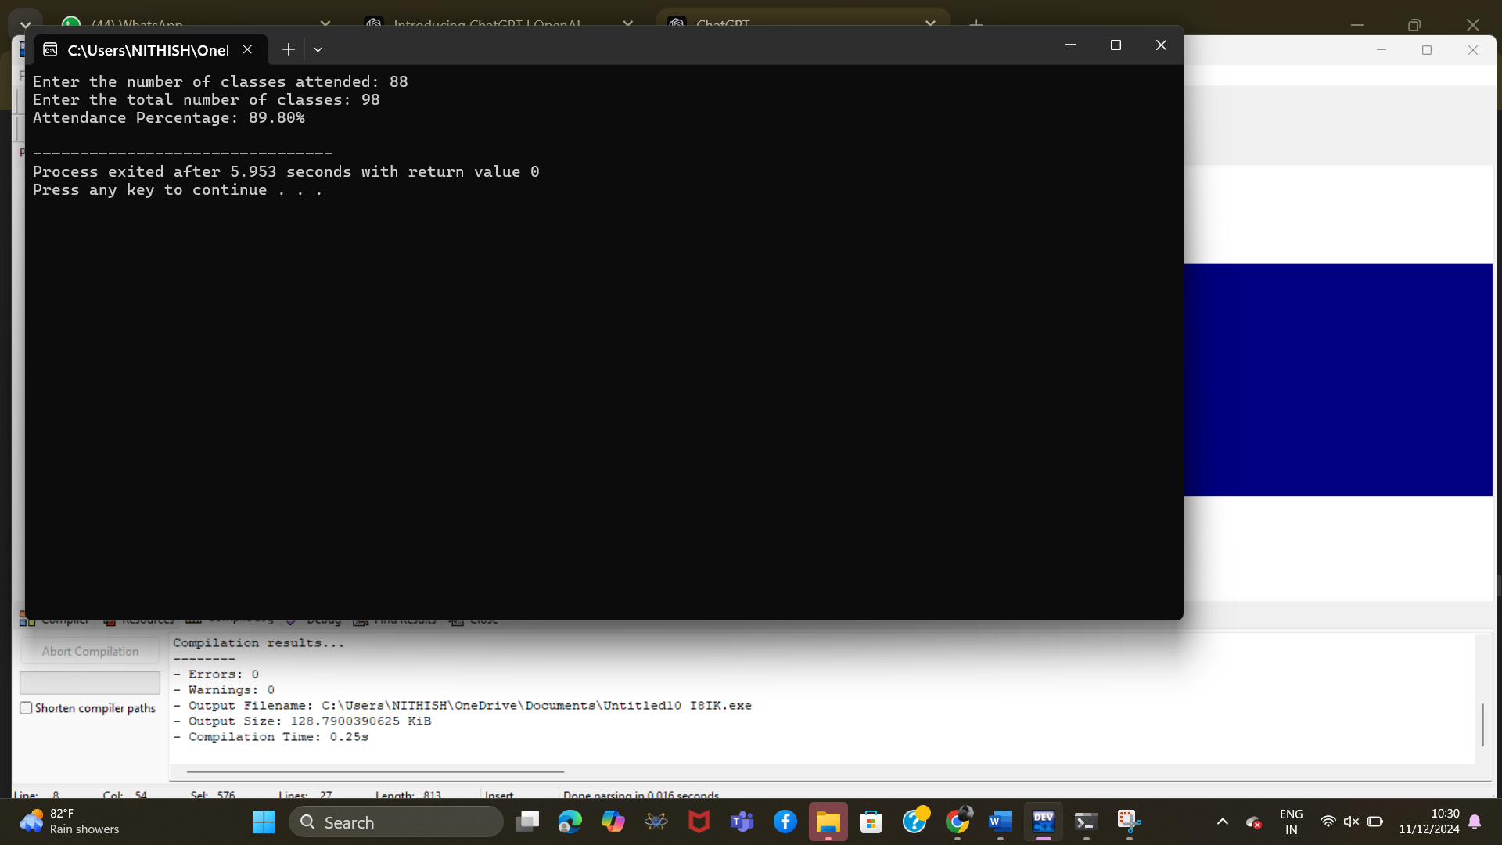

**EXP: 3 Currency Conversion**

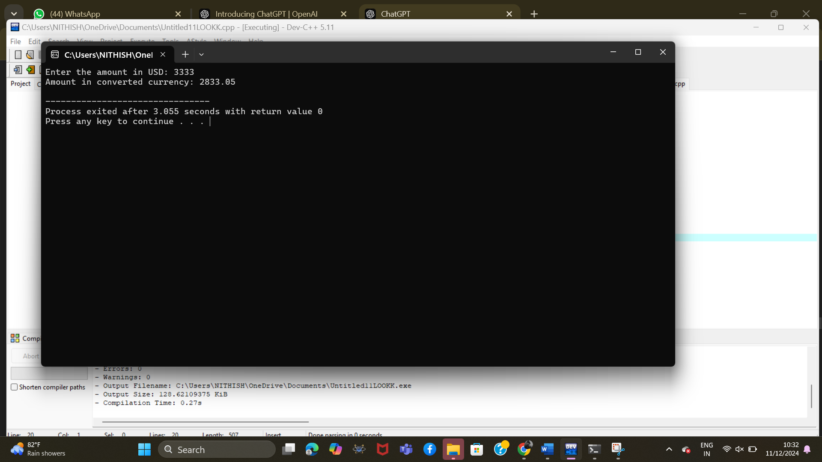

**EXP:2 . Discount on a Product**

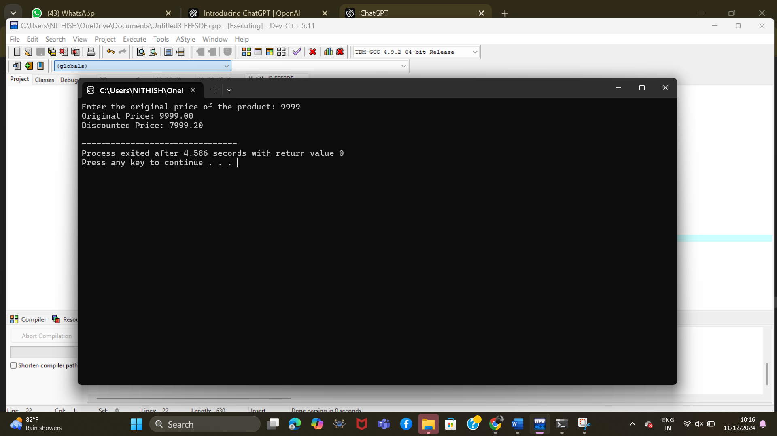

**EXP:1 BMI Calculator**

